**

**Final Report**

**Usman Zia**

24087

**Date:** 16/04/2023

**Supervisor:** Kartikeya Rana

**Teacher:** Marie Keary

*Report submitted in partial fulfillment of the requirements for the BSc in Computing at Dorset College.*

# **Declaration**

**The incorporation of material without formal and proper acknowledgement (even with no deliberate intent to cheat) can constitute plagiarism.**

If you have received significant help with a solution from one or more colleagues, you should document this in your submitted work and if you have any doubt as to what level of discussion/collaboration is acceptable, you should consult your lecturer.

**WARNING**: Take care when discarding program listings lest they are copied by someone else, which may well bring you under suspicion. Do not leave copies of your own files on a hard disk where they can be accessed by others. Be aware that removable media, used to transfer work, may also be removed and/or copied by others if left unattended.

Plagiarism is considered to be an act of fraudulence and an offence against Dorset College Quality Assurance Manual.

Alleged plagiarism will be investigated and dealt with appropriately by the Institute. Please refer to the Institute Handbook for further details of penalties.

*Collusion may be defined as more than one person working on an individual assessment. This would include jointly developed solutions as well as one individual giving a solution to another who then makes some changes and hands it up as their own work.*

|  |
| --- |
| **DECLARATION**:  I am aware of the Dorset College policy on plagiarism and certify that this thesis is my own work.  Student :  ________Usman Zia_______________________________________  Signed |

Failure to complete and submit this form may lead to an investigation into your work.

# **Abstract**

This section of the report should give the reader a concise overview of the project. It shouldn’t be not more than half a page and consist of the following :

* What was the aim of developing the application?
* What was the rationale behind the application?
* What is the background?
* What is the purpose of the application?
* What were the steps involved in the development of this application?
* Were user tests carried out throughout and after implementing the system? What did the testing results show?
* Is there any further development work that could be carried out?

# 

# **Acknowledgements**

In this section, you have the opportunity to thank your supervisor and the people that have been involved in the project.

***Example:***

*I would like to thank my supervisor, supervisor’s name, for giving me useful suggestions. His/Her support and guidance were extremely helpful since they provided me invaluable information on the best way to develop my project.*

*I would also like to thank my classmates and friends for all the help and support during this project development and over the past 3 years.*

# **Table of Contents**

**Declaration**1

**Abstract**2

**Acknowledgements**3

**Table of Contents**4

**1. Introduction (1 ½ pages)**6

**2. Requirements**7

2.1 Requirements 7

2.2 Requirements gathering 7

2.3 Requirements modelling 8

2.4 Feasibility 9

2.5 Conclusion 9

**3. Design**10

3.1 Introduction 10

3.2 Program Design 10

3.3 User Interface Design 11

3.4 Conclusion 12

**4. Implementation**13

4.1 Introduction 13

4.2 Implementation 14

4.3 Scrum Methodology 14

4.4 Development environment 14

4.5 Conclusion 14

**5. Testing**15

5.1 Introduction 15

5.2 Functional Testing 15

5.3 User Testing 17

5.4 Conclusion 17

**6. Project Management**18

6.1 Introduction 18

6.2 Project Management Tools 18

6.3 Reflection 19

6.4 Conclusion 19

**7. Conclusion**20

7.1 Introduction 20

7.2 Project Summary 20

7.3 Project Strengths and Weakness 20

7.4 Learning Outcomes 20

7.5 Further Development 20

**8. References**21

**9. Appendix**22

Appendix A 22

Appendix B 23

Appendix C - Consent Form 24

Appendix D - Ethics Form 28

# **1. Introduction (1 ½ pages)**

Scope of this project is to take a step forward against crimes where we can feel protective whilst we are occupied in a trouble or we acknowledge a doughy activity happening around us so in order to take actions against such activities occurring in our surrounding and to accomplish the security and stability of our area I came up with the idea of this application which will be introduced in coming weeks which in my perspective would be a huge step forward against climate activities.

In this project I used Android studio to achieve android application which is useful for reporting any incidents that were encounter around us anytime anywhere, I have also used many libraries like firebase authentication, fire store to store all the data in the database, also for designing XML is used which is very helpful and very useful when it comes to aligning or arranging your layout, every was gradient colours from gradient.io etc, and the next part was cheque if everything was functional or not maybe end of the app I was successfully able to upload all the user inputs along with their details in database.

# 

# **2. Requirements**

## **2.1 Requirements**

The first requirement that this project has is able to report something as soon as you see them happening, It was a challenge altogether to meet all the requirements like whatever you abuser is using this application they would be able to work create their own account and also they can access their profile through this application as well and as they are locked in if they encountered anything started would be able to report it straight away and very easily now with this being said this application has a requirement of reporting just within one kilometre of the users radius no well any misuse of this application but at the end of the day all the data in the stored in the database and this application won't allow user to go outside the range of fund kilometres because the main requirement of this application is to report around their surrounding but not which is not under their range.

## **2.2 Requirements gathering**

**2.2.1 Similar applications**

Research any three similar applications and include the following for each:

* Descriptions

1. Citizen - This app enables users to report incidents in real-time and receive safety alerts from other users in their area.
2. SafeCity - This app enables users to report incidents of sexual harassment, violence, and other crimes, and provides safety tips and resources.
3. Incident Reporter - This app enables users to report incidents such as road accidents, fires, and other emergencies to the relevant authorities.

* Advantages

Quick and easy reporting: With these apps, users can quickly and easily report incidents using their mobile devices, without having to make a phone call or send an email. Improved response times: By providing real-time information about incidents, these apps can help authorities respond more quickly and effectively to emergencies and other situations. Overall, incident reporting Android apps can help to improve communication and collaboration between users and authorities, leading to more effective incident management and increased safety and security for all.

* Disadvantages

False or malicious reporting is one of Incident reporting app’s drawwback as it can be vulnerable to false or malicious reporting, which can waste resources and divert attention away from genuine incidents.Secondly, overreliance on technology like its a risk that some users may over-rely on the app for reporting incidents, rather than seeking immediate help or contacting emergency services directly. It's important to know that these potential disadvantages may vary depending on the specific app and the context in which it is used. It's always a good idea to read reviews and do your own research before using an incident reporting app.

* Screenshots

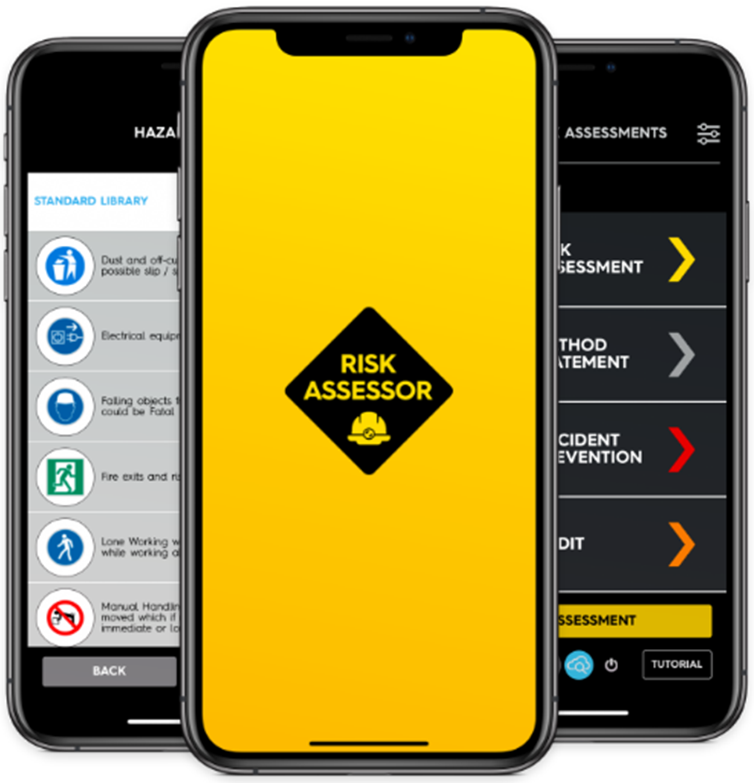 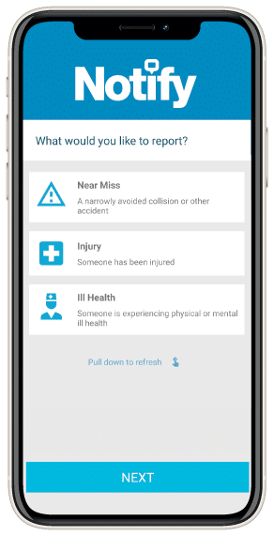

**2.2.2 Interviews**

After showing his application to a few friends they did mentioned that this could be very useful but as I mentioned above there are people out there who don't miss a chance to fool you around/ scam you but people should be happy that an application like this can save life which probably you don't even know, that you’re going to come across say in the middle of the road or somewhere something bad happening let's say I am in the middle of the night and it's hard to find somebody and by any chance if I find someone they can made this possible, even though as this application is made very easy to operate so it’s a good way to inform someone about your situation and it can take literally up to 10 seconds to just after board the situation and then the help will be on their way this is the response that I got from one of the friends, however this app can be improved and can we take him to the next levelbought in a security and feature wise.

**2.2.3 Survey**

Due to shortage of time it was not possible to make a survey, however in my flip flops I have talked with my teachers and with friends and about 80% was positive but since it found abilities at scammers out there, Still chance of getting fooled or scammed are there, So to avoid such happening with I have done is that From current location the range of 1 kilometre radius that means they can't go more than one kilometre radius and can't say that the problem is in another county etc, Also this application anonymously takes location of the users current address, but what user knows is that it only takes the incidents location its only a preventive measure if somebody is trying to make a fool out, there is a good chance you can fool them too.

## 

## **2.3 Requirements modelling**

**2.3.1 Personas**

As of this application is simple enough that a illiterate person can also use this. Peacock about the users equipment so I would say that in today's age this is a necessity, and the good thing is it gives you ability to write or explain whatever the scenario is also it can be treated as soon as it can. now according to the survey which I did in my class this application completes the requirements of all ages, it does not matter where you live or what age you are once you have a problem you take your phone out and just reported straight away it is anonymous and nobody's going to know that who reported but they will know that it was being reported without somebody attending a Garda station.

**2.3.2 Functional requirements**

- signing up / logging in using e-mail and password.

- Storing your credentials in the database, like your e-mail, password, full name, gender, phone number.

- reset link in case you forgot your password it will be sent on your e-mail provided.

- main screen has all necessary tabs and fields.

- search bar is also provided within the application so you can right what you're looking for and it will come right up.

- it has maps layout on the reporting.

- permissions for location

- a marker on your location which is not draggable until unless you move.

- another marker which can be implemented just once and should be within a radius of 1 kilometre.

- Talking of 1 kilometer there will be a blue circle indicating the area where you can report or drop a marker, Google Maps as a blue circle around current location.

- the marker is draggable.

- after the marker is dragged and then dropped out of a different location within one kilometre radius it will automatically update the longitude and latitude.

- if Parker is dragged hold of 1 kilometre radius it will be destroyed.

- current location, incident location, distance between both of the locations will also be saved in the database.

- if distance in metres will be more than 1000, the report will be ignored.

- after selecting the location user will be directed on a window where they can answer multiple questions man can explain the scenario, which is also served in the database.

- When users will navigate on profile tab, I would be able to see their credentials and their data like name e-mail phone number and stuff.

- there is a built in function to call 112 if this is a very serious emergency.

- if user is not signed out, every time they will open the application it will not ask them to sign in again.

- sign out tab is also provided in a where user can sign out, obviously they have sign back in again.

- In order to navigate between different windows, that is a bottom navigation there all the windows tab provided for easy access and saving time.

**2.3.3 Non-functional requirements**

* Usability

its application holds a very easy to use interface, as this app is built for people of all ages, so you get very important to keep the flow consistent and not confuse any of the users, by using this app user can report within a couple of seconds.

* Performance

The performance efficiency of this code depends on various factors such as the size of the data, the complexity of the layouts, and the processing speed of the device running the application. However, the code is well-structured and optimized. The RecyclerView is used to display the list of items efficiently by reusing the views. The search feature also uses a separate list to display the search results and notify the adapter only when the search results change, which is improving performance. Also this application uses very efficent APIs and services such as provided by google.

* Security

The code is using Firebase Authentication to handle user registration and login, which is a secure and widely-used authentication solution. The code is also using Firebase Firestore to store user data, which provides a secure, scalable, and reliable database solution. The code is performing input validation to ensure that required fields are not empty, which is a good security practice to prevent invalid data from being submitted.The code is not currently implementing any measures to prevent common attacks, such as cross-site scripting (XSS) or SQL injection. These types of attacks can be mitigated through input sanitization and prepared statements. However with further improvements all the security features can be implemented.

**2.3.4 Use Case Diagrams**

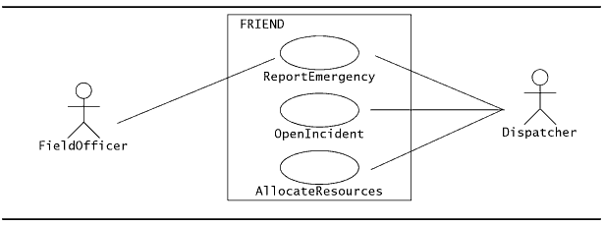

Look at the US case diagram provided above it can be seen that when a dispatcher in our case is a user Make a report application the incident is open which there and then allocated to a officer, Which will be signed it with such assignment sort out the problem whoever is closest.

## 

## 

## **2.4 Feasibility**

This application is a very feasible approach for anybody who is using it to report any incident it is very visible and very suitable for people of all ages and it can be done in a couple of seconds. One of the achievements that I am expecting from this application is that it should be proven to be efficient and feasible in the sensitive cases and also in emergency cases. This could be a very huge step forward in today’s world with the help of technology once the technology will be in place and working perfectly we can urge peoples to install this application which could save lives and many violence and threats to our society. There have been many cases where some people don't mention /report any kind of criminal activity that they are aware of because they're afraid to report but with the help of this application people will a great opportunity to express what they're going through or what is bothering them. If we have a glance on this table provided below it can be seen that there are over 58% of the crimes which are never reported and by the way this is the report from a survey between 2006 to 2010. by looking at this table we can tell dash more than half of crimes are never reported.

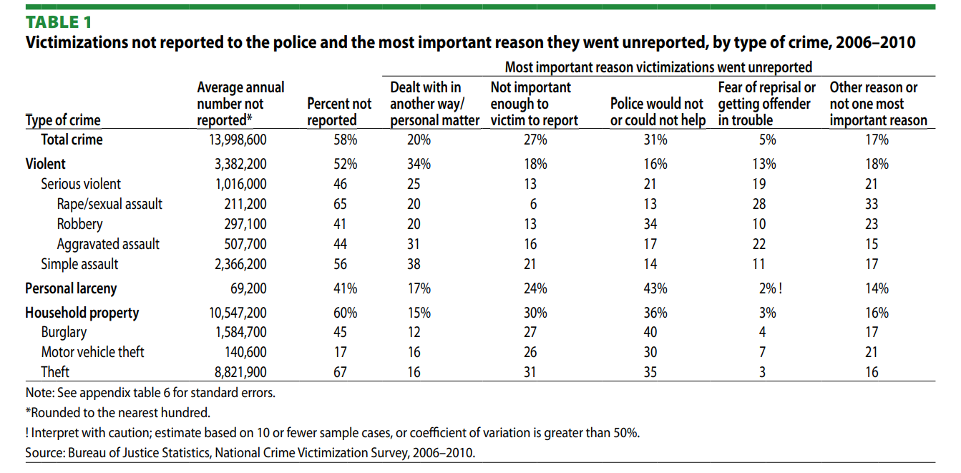

## **2.5 Conclusion**

To conclude this is a very efficient and responsive application and According to my search and knowledge there isn't any application or web application available so far in Ireland to report incidents as you experience them. obviously we do have 911 service but that sometimes takes between 4 to 6 minutes to attend reporters call. I think these 4 to 6 minutes are very important even every single second is important when it's an emergency or sometimes if you see or reckon any kind of crime like racial equality, robbery, physical violence, sexual violence, human trafficking some other crimes like selling illegal stuff etc. And me know about this we can just use this application which will be really helpful and efficient and can save very important Lifes Just by saving time and reporting at the perfect time Without anyone knowing who reported or how police is on site.

# **3. Design**

## **3.1 Introduction**

This application is designed by keeping in mind user friendly layout so the user is not confused and the design layout provided very consistent flow throughout the application from the start screen all over to reporting, signing out and everything.

The application’s design is divided into:

1. Program Design

ConstraintLayout, Linear Layout, Relative Layout with a background image set to a drawable resource. Also there is a start layout which is intended for use in the SplashActivity of a this Android application, which serves as a visual introduction to the app that appears briefly while the app loads, then **Toolbar** is used to display the title of the screen and provides navigation back to the previous screen. The **BottomNavigationView** is used to allow users to switch between different screens within the application. Also **MapView** is used to display a Google Map with the location selected by the user. A nice low radius is given within one kilometre range, Which is very nice round and is very user friendly.

1. User Interface Design.

This code defines a layout with a CardView widget that has a rounded corner and a shadow effect. Inside the CardView, there is a ConstraintLayout widget that contains a TextView with black text, a font size of 16sp, and a top margin of 20sp, The use of a gradient background, a custom toolbar, and a custom search view, The layouts also contains a Toolbar widget with a white title, a green background, and a shadow effect. Overall, this design is simple and clean, with a focus on typography. The use of a CardView with a rounded corner and shadow effect provides a modern and attractive look.

## 

## **3.2 Program Design**

This section refers to the technical design of the application to make the programming and coding of the application more straightforward.

**3.2.1 Technologies**

The technologies being used to create this application are:

These technologies were chosen because, This is the primary framework for developing native Android applications. So XML is used to define the layout and structure of user interface elements in Android. Then Several ConstraintLayout is used which is a layout manager in Android that allows you to create flexible and dynamic layouts. Also RecyclerView is a view group for displaying large sets of data that can be scrolled efficiently and easily so recyclerview is used.

* Android SDK: This is the primary framework for developing native Android applications.
* XML: It is used to define the layout and structure of user interface elements in Android.
* ConstraintLayout: It is a layout manager in Android that allows you to create flexible and dynamic layouts.
* RecyclerView: It is a view group for displaying large sets of data that can be scrolled efficiently.
* Toolbar: It is a widget in Android that provides a top app bar for easy access to common actions.
* SearchView: It is a widget that provides a search interface within an app.
* MapView: It is a view that displays a map with data obtained from the Google Maps API.
* BottomNavigationView: It is a widget that provides a bottom navigation bar for navigating between different views or screens within an app.
* Google Maps API: It is used to obtain map data and services, such as geolocation and geocoding, in the MapView.

Overall, this code uses several Android UI components and layout attributes to define a view hierarchy that can be displayed to the user in an Android app. Other possible technologies that could have been used were the application is expected to handle large amounts of data or user traffic, then certain technologies might not be suitable. For example, using a traditional SQL database might not be the best choice for a high-traffic application that requires fast reads and writes

**3.2.2 Structure of React/Unity/Android/etc**

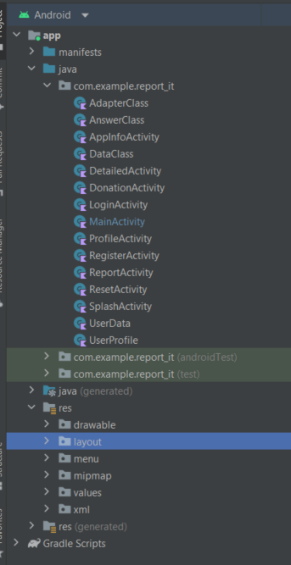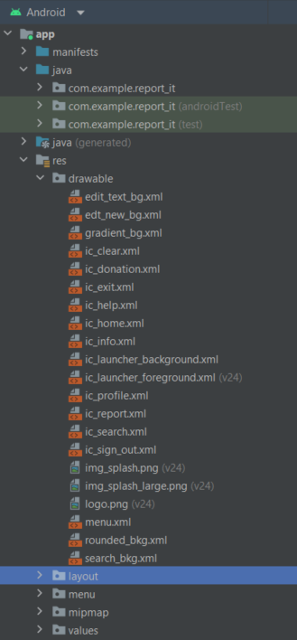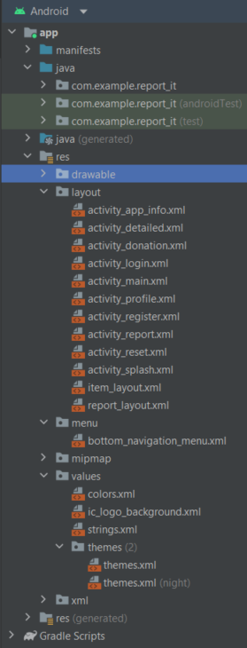

It can be seen in the screenshots attached above the mainly there are 4 folders.

1: com.example.report_it

Which holds all the kotlin class files.

2: drawable:

Next is drawable folder which contains everything like logos, any screenshot or images, icons etc that you would like to be displayed anymore application.

3: menu:

Folder menu has the design for the bottom navigation windows which is a very easy and accessible way to change through the windows.

4: layout:

next layout folder which is essential with every Kotlin activity so different things like text, edit text, buttons, checkboxes etc can be added and can be organised.

**3.2.3 Design Patterns**

Observer Pattern is used for this design implementation to notify a set of observers when a particular event occurs. This was useful as i had a set of objects that need to be notified when something happens, such as when data changes and stuff, So i thought it’d be the best approach. Below there are screenshots attached as it can be seen that the application was designed in figma but with the time the application changed a little bit So I added a few more activities/ windows in my Android application so it looks a little more than what it is in the screenshots.

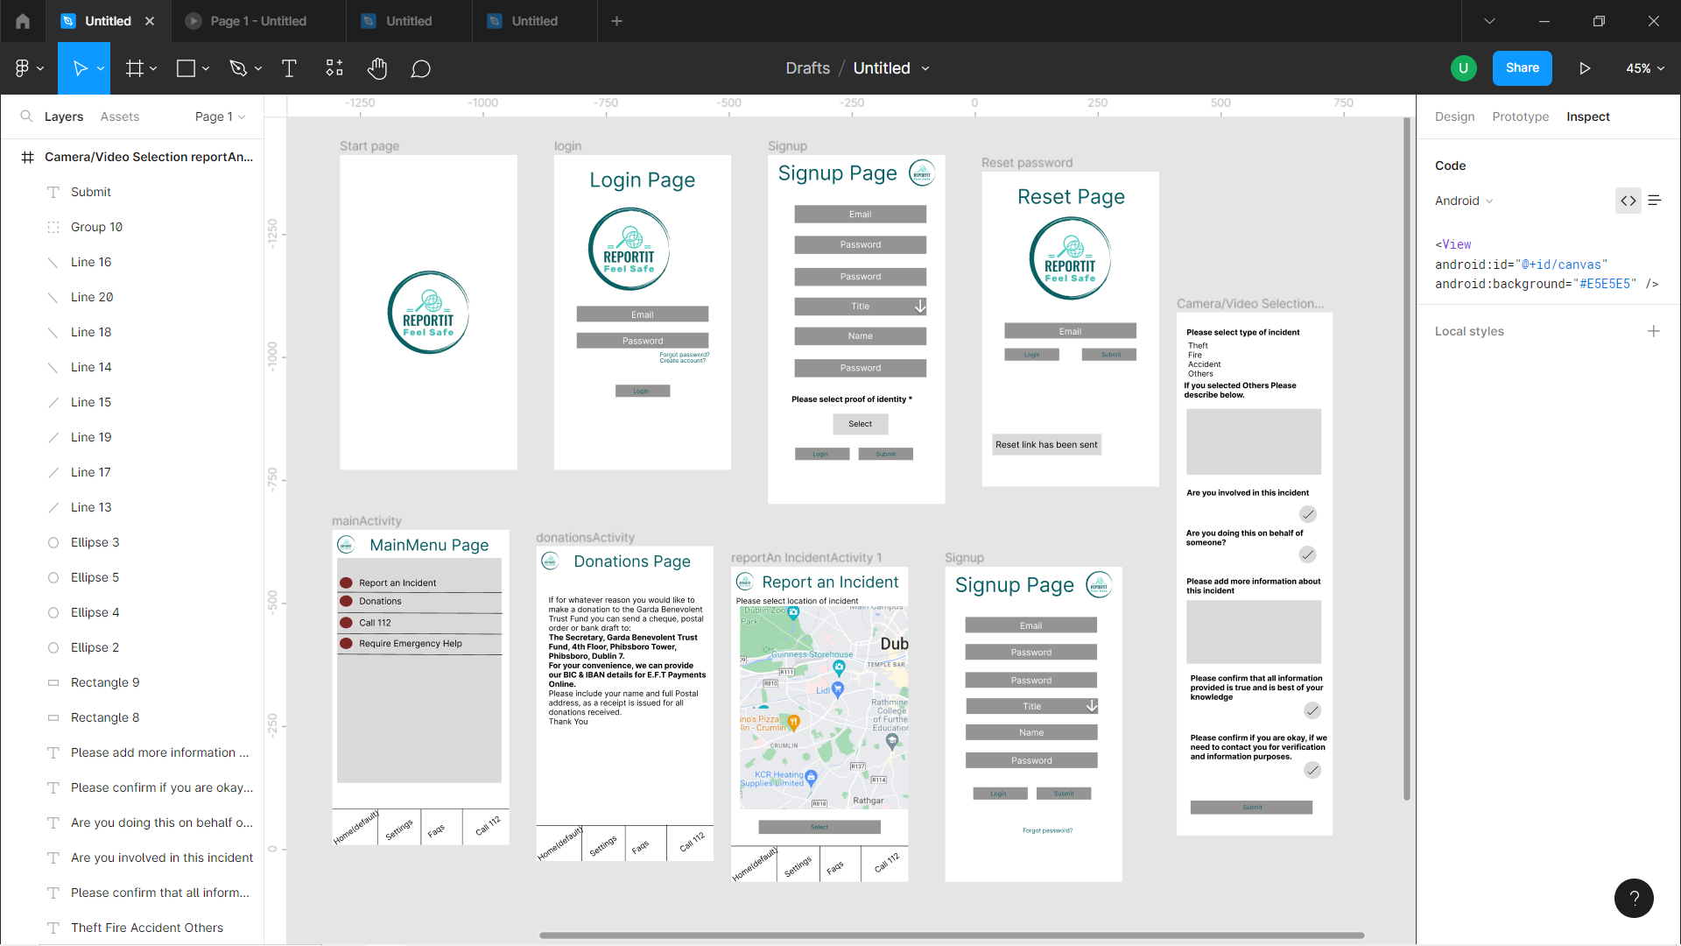

**3.2.4 Application architecture** 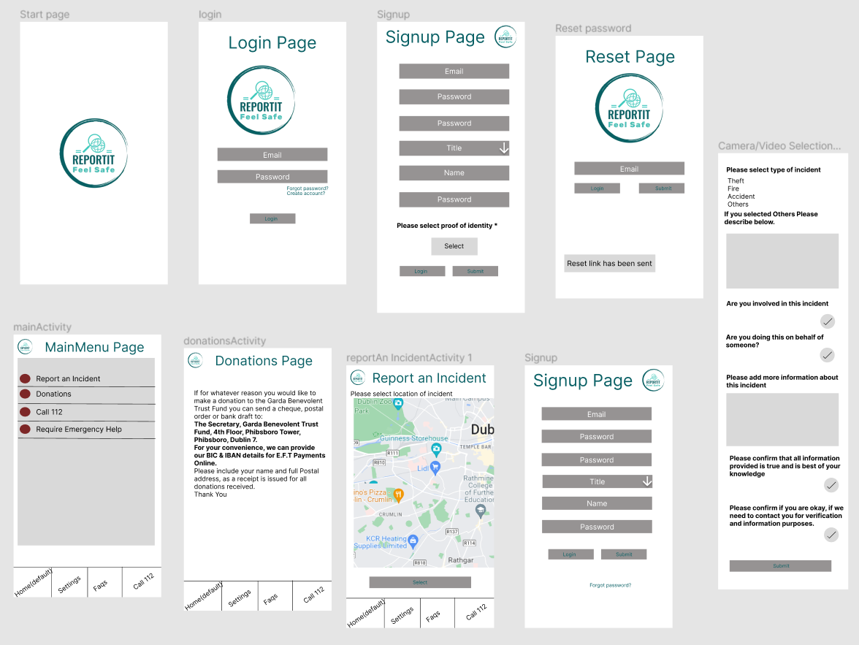

**3.2.5 Database design**

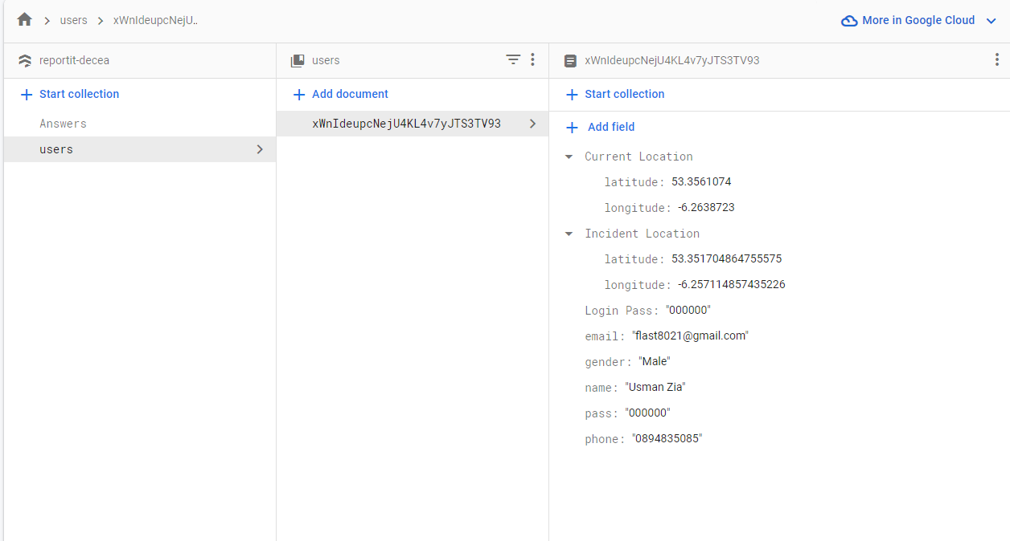

## 

## **3.3 User Interface Design**

Below I have added on the the quiet designed making process, that how I created what I created I don't word platform added so it's all mentioned below.

**3.3.1 Wireframe**

<https://www.figma.com/file/5eDA6haQPjiH9k3voStM8x/Untitled?node-id=0%3A1&t=cJAgAdxf0aBiOTO1-1>

I’ve added link to my figma boy framing for this particular application and it can be seen in the screenshot below as well that it is a consistent flow between the activities or windows you can browse the link above to get a better idea.

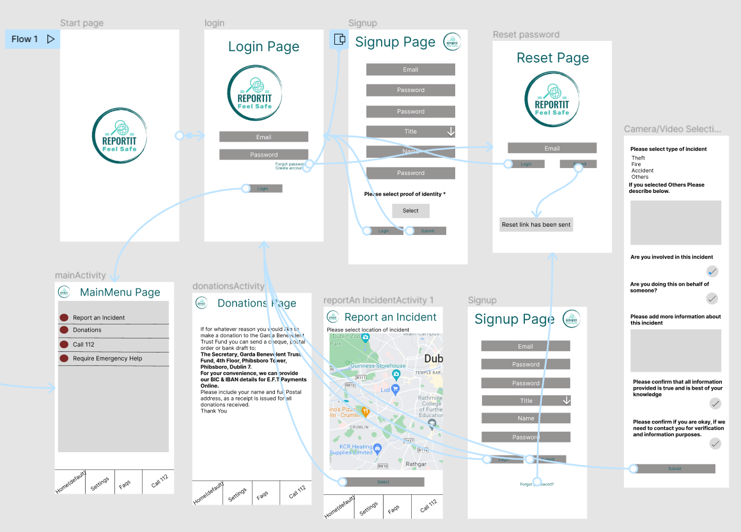

**3.3.3 Style guide**

The color scheme used in this layout includes a gradient background, which is defined in the **android:background** attribute of the ConstraintLayout. The toolbar has a solid color background of **#0F7D6E**, which is a dark shade of green. The text color of the toolbar title is set to white using **app:titleTextColor="@color/white"**.

The SearchView has a custom background defined in **android:background="@drawable/search_bkg"**. It also has a search icon defined in **app:searchIcon="@drawable/ic_search"** and a close icon defined in **app:closeIcon="@drawable/ic_clear"**.

## **3.4 Conclusion**

To conclude the design and the layout are very consistent and have a nice shadow background, every window has a very nice gradient background which is a mixture of two colours greenish and whitish colour which are set at the angle of 90 degrees giving this nice colour, then all the text input have a border and a round corners layout with a nice background colour which gave it everybody elegant and attractive design. reason to choose this sign is to implement the latest level of design nowadays and the more user friendly interface the better the user experience so it's basically the focus is on the user experience as there are many apps out there which all helpful but they're not user friendly which is kind of a big drawback for any application as it's design is the man thing that the normal user sees.

# **4. Implementation**

## **4.1 Introduction**

This app is implemented using Google services like firebase authentication, Google Maps Google fire store, Figma, obviously Kotlin was the main language that I used for coding, Most importantly this application is capable of storing all the data cloud using Google services.

## **4.2 Implementation**

**Setting up the development environment:** This involves installing and configuring the necessary software and tools required for Android development, such as Android Studio, the Android SDK, and any necessary libraries and plugins.

**Designing the user interface:** This involved creating the layout and design of the application using Android's user interface framework, which includes XML-based layouts and widgets such as buttons, text fields, icons, checkboxes and images etc.

**Implementing the application logic:** This was writing the code to handle user interactions, perform actions, and manage data within the application. This also involved writing Java or Kotlin code to handle events, as well as using Android's built-in APIs and libraries.

**Testing and debugging:** I testing the application on a variety of devices and emulators to ensure that it works as expected and is free of bugs and errors. This involve using Android Studio's debugging tools and writing automated tests to check the functionality of the application.

**Deployment:** This involves packaging the application into an Android APK file and uploading it to the Google Play Store or other app stores for distribution to users but that is not done yet, However an apk file is provided on [github](https://github.com/flast8021/reportit_apk).

## **4.3 Scrum Methodology**

Scrum is a popular agile methodology used in software development projects. It emphasizes teamwork, collaboration, and iterative progress toward a well-defined goal. The Scrum process typically involves roles, artifacts, and ceremonies, The type of Scrum methodology that i used was a self-organizing individual responsible for delivering a potentially shippable product increment at the end of each sprint which was myself ofcourse as this was not a group project.

## **4.4 Development environment**

The development environment which is used for Android application is called Android studio obviously before using this editor we need Java development kit to be installed and then indoors hot food market as well which is a set of tools required to build an Android application, which is pretty handy as it comes with built in home functionality to add fire store authentication etc in this editor, actually seen below that Git option is available instead you can handle the upload to github without any hassle, also as I already had my GitHub set it up so I didn't face any difficulties for such project.

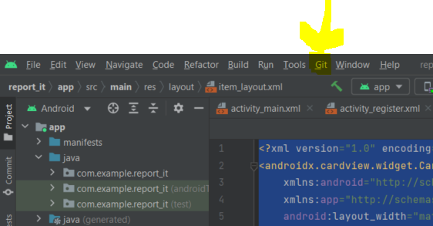

## **4.5 Conclusion**

To conclude it was a little more complex without the built in functionality of Android studio, But with the help of features like get and fire store that you can use from the tools stab at the very top of the Android Studio’s window. Properly working reporting application was created which was able to perform CRUD functionalities within the application.

# **5. Testing**

## **5.1 Introduction**

Of course with every application the most important part is to test if the implemented functionality are working or not, what you expect from the software is coming as an output or not. Most of the times we do not dig too deeply into the testing bit but it is a very essential part of a project or a software that it should be tested. As an application itself has No functionality until unless implemented properly, Sometimes the output is not the same what we expect so it is only recommended to test which was done throughout the development of this application to avoid any further errors and difficulties there are two types of testing.

1. Functional Testing

2. User Testing

Functional testing is a type of software testing whereby the system is tested against the functional requirements. The app is tested by looking to see if the actual output for a given input corresponds with the expected output. The tests should be based on the requirements for the app. The results of functional testing can indicate if a piece of software is functional and working, but not if the software is easy to use.

User testing looks to see if a piece of software is easy and intuitive for the user.

## 

## **5.2 Functional Testing**

This section describes the functional tests which were carried out on the app. These functional tests can be categorised as: (whatever is relevant to your app)

* Navigation
* Calculation
* CRUD (Create, Read, Update, Delete)

Functional testing generally uses a Black Box Testing technique which means that the internal logic of the system being tested is not of interest to the tester. The tester is only interested in whether the actual output agrees with the expected output.

### 

**5.2.1 Navigation**

|  |  |  |  |  |  |
| --- | --- | --- | --- | --- | --- |
| Test No | Description of test case | Input | Expected Output | Actual Output | Comment |
| 1 | Bottom Navigation Menu | Item 3 | Open donation activity | Opened donation activity | working |
| 2 | signout | Item 6 | Signout the user | Signed-out the user | working |
| 3 | Search iitem | Top search bar | Search as user is typing | Searched as user is typing | working |

**5.2.2 Calculation**

|  |  |  |  |  |  |
| --- | --- | --- | --- | --- | --- |
| Test No | Description of test case | Input | Expected Output | Actual Output | Comment |
| 1 | User current location marker | default | Should not move | Didn't not move | working |
| 2 | Incident location marker | Long click on map | Create a marker | Created multiple markers | Not working |
| 3 | Incident location marker | Long click on map | Create a marker | Created single markers | working |

**5.2.3 CRUD**

|  |  |  |  |  |  |
| --- | --- | --- | --- | --- | --- |
| Test No | Description of test case | Input | Expected Output | Actual Output | Comment |
| 1 | Register new user | Register fields | Save in firestore | Didn’t Saved data in firestore | Not working |
| 2 | Register new user | Register fields | Save in firestore | Saved data in firestore | working |
| 3 | Retrieving user data | Profile activity | Retrieve data from google firestore and dhow them in android aoo | Data Retrieved | working |

**5.2.4 Discussion of Functional Testing Results**

The few birds mentioned above that wasn't working was mainly two things the first thing was the incident marker that user can implement by long clicking anywhere on the map fit in one kilometre radius at the problem was it was creating more than one markers on the map and sometimes you will could make marker outside the one kilometre radius. so I had to fix it by implementing a if statement and I cheque that if a market exist then don't make more markers and it eventually worked.

the second thing that you did a hassle for me was just registering a new user in the firestore, However I have done it before but still it was giving me a bit of time the only thing I was missing was calling off the fire store variable in my **onCreate()** method, after calling add method it worked for me.

## 

## **5.3 User Testing**

To conduct user testing for this application, I follow these steps:

**Define the user testing objectives:** Determining what aspects of the app i want to test and what specific feedback i was looking for. This included testing the app's usability, accessibility, design, features, and overall user experience.

**Set up the testing environment:** I Setted up a quiet and comfortable space where participants(friends) can test the app without distractions. Everybody had a smartphone so we after finishing the application it was checked for bugs and stuff.

**Collected feedback:** After the testing session, collect feedback from participants through interviews. Asked participants about their overall experience with the app, what they liked and disliked, and any suggestions they have for improvement.

Analyze and implement feedback: Analyze the feedback collected from the testing session and use it to make improvements to the app. Prioritized the feedback based on its impact on the user experience and address any critical issues first.

By conducting user testing, i could ensure that Report_It meets the needs and expectations of its users and provides a seamless and enjoyable user experience.

## 

## **5.4 Conclusion**

To conclude testing is a very important bit and it really proved helpful especially when I did the user testing bit it gave me a chance where different users can what their thoughts on the table and I could see how can this application be improved. User testing provided very valuable insights into the usability and user experience of this application, and helped me identify areas for improvement. Based on the user testing results, i refined the application to better meet the needs of its users and enhance its overall usability.

# **6. Project Management**

## **6.1 Introduction**

In this chapter, discuss how the project was managed. Describe the phases of the project, starting from the initial idea, research, requirements gathering, the specification of the project, the design, implementation, and the testing phase. Also mention what tools were used to manage the project such as Trello, GitHub, and if you kept a journal to assist in project management.

This section should describe each of the following phases. Explain any issues that arose for each phase if any:

**6.1.1 Proposal**

**6.1.2 Requirements**

**6.1.3 Design**

**6.1.4 Implementation**

**6.1.5** **Testing**

The project management process for this application involved several steps, including:

**Defining project scope**: This was to define the goals and objectives of the project, as well as identifying the resources required to complete it.

**Creating a product backlog:** I created a list of all the features and functionalities that the application needs to have to meet the needs of the end-users.

**Designing**: in order to design a project I used figma which gives you a very nice wire frame flow capability well you can design the whole app structure and then you can navigate through different windows now to get an idea of what you will be here developing.

**Coding:** Coding bit was not too hard as I have already have experience and I have already done some Android applications so it was not a big challenge however there was a few bits that I have mentioned above was a little long confusing but at the end of the day I figured the mouse and it was deployed successfully

**Testing & finalising:** the last thing was to test the application and see the working of it and see if there's anything missing any functions not working or any other bits need to be tested before presenting the application, eventually I was able to achieve a proper functioning reporting application.

## **6.2 Project Management Tools**

Wrike is a project management tool that offers features such as task management, time tracking, project planning, and team collaboration. It provides a range of templates to help teams get started quickly and also integrates with other tools such as Google Drive, Dropbox, and Salesforce. So I find it very handy I used to manage my time and see where I am with the project then it can help a lot throughout the whole process after helping and achieving and testing and everything

## **6.3 Reflection**

this project involved and designing, planning, implementing, testings, error findings, reimplementing multiple times and then testing if everything is functional and it took almost 8 to 9 hours a day working constantly two weeks make this thing functional and as this was not a group assignment so it there was a lot of burden and a lot of requirement which need to be done on it so obviously I had to work think about what a user would want from the application so after a user testing there was few bits that I had to add or let it change the design a little bit but now it is probably functioning and it's been submitted.

## 

## **6.4 Conclusion**

In order to conclude this project was a complex project and it was very handy using the project management tools and techniques because it was very important to keep track of what have been done and what haven't done so far and using tools like Wrinkle as I mentioned above, These tools provided a range of features that facilitated me with project planning, scheduling, etc.

# 

# **7. Conclusion**

## **7.1 Introduction**

By doing this project I have learned to manage the time and especially working on the user interface thing which is ready important and I I'm also thinking to implement more features in future like ability for a user to add pictures or videos off an incident or whatever the situation is so that the officer or the admin have a clearview and has better knowledge of what is going on.

## **7.2 Project Summary**

This project was again challenging as with the Android studio sometimes the layout and the referencing very confusing and especially when you use different APIs into your application and you are implementing different libraries into word application then it's gonna get complicated enough that you have to be very careful otherwise if you are referencing one ID but it will take another ID from another library you have imported so that was something that I had a problem when I was working on this project and it almost took me a whole day to figure out the problem and the problem was not even that sophisticated it was just the wrong referencing in one line of the code which made the whole not of the application to crash and not work.

with all that said it was also a lot of fun and learning at the same time to cause including the more you practise the more you learn.

## **7.3 Project Strengths and Weakness**

This project is a combination of different thinks that could be used in any application for example it has drop down menus, it has a bottom navigation tab, it has a toolbar, then you can also scroll the application as well, then you have a search bar, there is a map layout you can drop markers and stuff, Then it will also calculate the distant locations and everything will be saved in the database which makes this project where is unique and complex at the same time.

## **7.4 Learning Outcomes**

while doing this project I learned how you can take the data from the database store somewhere remotely and then you can retrieve the data into a different activity or a window I also learned how you can make different database fields and values just by few line of codes without you designing and structuring the database.

## **7.5 Further Development**

In the coming future I plan to add more food into this application even this was the first version of the application It is still quite handful and it is functional the most importantly and the best thing is it can be used anywhere once you have Internet connection and it will get your report submitted as soon as you will submit the report, I am also planning to add a function being this application that even if there is no Internet availability it will take the report it will submitted it but it will wait for the Internet to come live as soon as the device will get the Internet connexion all the data will be uploaded into the database without user had to do anything, also adding the functionality of inserting picture as small video is also my plan.

# **8. References**

[*https://moodle.dorset.ie/course/view.php?id=414#section-2*](https://moodle.dorset.ie/course/view.php?id=414#section-2)

[*https://github.com/flast8021/reportit_apk*](https://github.com/flast8021/reportit_apk)

[*https://github.com/flast8021/report_it*](https://github.com/flast8021/report_it)

[*https://stackoverflow.com/questions/49969319/kotlin-difference-between-constant-in-companion-object-and-top-level*](https://stackoverflow.com/questions/49969319/kotlin-difference-between-constant-in-companion-object-and-top-level)

[*https://firebase.google.com/*](https://firebase.google.com/)

[*https://cloud.google.com/docs*](https://cloud.google.com/docs)

[*https://developer.android.com/kotlin*](https://developer.android.com/kotlin)

# **9. Appendix**

## **Appendix A**

<https://www.figma.com/file/5eDA6haQPjiH9k3voStM8x/Untitled?node-id=0%3A1&t=hcX11r3yzi6UXxud-1>

## 

## **Appendix B**

[*How to create an Options Menu in Android Studio (Kotlin 2020)*](https://youtu.be/SbNQxPDUWaI)

[*dropdown menu in kotlin (Android Studio)*](https://youtu.be/Nbjb_se6_Xc)

## 

## **Appendix C - Consent Form**

**Research Informed Consent Form 2023**

*(to be filled by researcher)*

**TITLE OF STUDY**

______________________________________________________________________

**PRIMARY RESEARCHER**

Name: Usman Zia

Department: Computer Science

Address: 28 Hardwick street Dublin 01

Phone: 0894835085

Email: flast8021@gmail.com

**PURPOSE OF STUDY**

_The purpose of study i

**PROCEDURES**   
  
______________________________________________________________________

______________________________________________________________________

______________________________________________________________________

**RISKS**  
  
______________________________________________________________________

______________________________________________________________________

______________________________________________________________________

**BENEFITS**  
  
______________________________________________________________________

______________________________________________________________________

______________________________________________________________________

**CONFIDENTIALITY**

Please do not write any identifying information.

Every effort will be made by the researcher to preserve your confidentiality including the following:

* Assigning code names/numbers for participants that will be used on all research notes and documents
* Keeping notes, interview transcriptions, and any other identifying participant information in a locked file cabinet in the personal possession of the researcher.

Participant data will be kept confidential except in cases where the researcher is legally obligated to report specific incidents. These incidents include, but may not be limited to, incidents of abuse and suicide risk.

**CONTACT INFORMATION**   
If you have questions at any time about this study, or you experience adverse effects as the result of participating in this study, you may contact the researcher whose contact information is provided on the first page. If you have questions regarding your rights as a research participant, or if problems arise which you do not feel you can discuss with the Primary Researcher directly by telephone at _______________________ or at the following email address _______________________.

**VOLUNTARY PARTICIPATION**  
Your participation in this study is voluntary. If you decide to take part in this study, you will be asked to sign this consent form. After you sign the consent form, you are still free to withdraw at any time and without giving a reason. Withdrawing from this study will not affect the relationship you have, if any, with the researcher. If you withdraw from the study before data collection is completed, your data will be returned to you or destroyed.

**CONSENT**  
I have read and I understand the provided information and have had the opportunity to ask questions. I understand that my participation is voluntary and that I am free to withdraw at any time, without giving a reason and without cost. I understand that I will be given a copy of this consent form. I voluntarily agree to take part in this study.

**Participant's Signature** _____________________________ Date __________   
  
  
**Researcher’s Signature** _____________________________ Date __________

## **Appendix D - Ethics Form**



**Ethics Approval Form**

**Dorset College**

*Dorset College requires all research activities to be subjected to ethical scrutiny. The purpose of this Ethics Form is to inspire and assist researchers to design and undertake their research in the most ethically appropriate way.*

**Section 1**

**1. Application Details**

|  |  |
| --- | --- |
| Name | Usman Zia |
| Student Number | 24087 |
| Programme | Bsc. In Computing |
| Year of study | Year 3 |
| Supervisor | Kartikya Rana |

|  |  |
| --- | --- |
| Research Project title | Incident Reporting |
| Start Date | 12/09/2022 |
| End Date | 16/04/2023 |
| Funder (if applicable) |  |
| Date of Submission | 16/04/2023 |



**Section 2**

**Research Project Details**

2.1 Research Objective/Brief (300 words):

|  |
| --- |
| The objective of this research was to get User’s Identify the key features and functionalities required  in an incident reporting application, based on a review of existing literature and user needs  Assessments,So I Developed an Android application that meets the identified requirements and  incorporates best practices in user interface design and software development. Evaluated the usability  and effectiveness of the developed application in improving incident reporting processes,  such as timeliness, accuracy, and completeness of incident reports. Assessd user satisfaction with the  application and identify areas for improvement based on user feedback. Provide recommendations for  further development and implementation of the incident reporting application, including potential  integration with other systems and processes. Also To design, develop, and evaluate an Android  application for incident reporting that is user-friendly, efficient, and effective in improving  incident reporting processes and outcomes. So by achieving these objectives, the research  contributed into the development of an effective and user-friendly incident reporting  application that could help organizations improve their incident reporting and management  processes, leading to better outcomes for all stakeholders involved. |

2.2 Research Methods to be employed:

|  |
| --- |
| (a) Where will the research be carried out?  In our local comunity.  (b) What research methods would you employ in the course of your research (*interviews, surveys, focus groups, etc*):  I’ve already anticipated in interview methods and group survey which was very helpful  altough, But i plan to Carry on a few surveys. |

2.3 Proposed Participants

|  |
| --- |
| (a) How many participants do you plan to include:  7-10  (b) Will the research use any of the following participants:  i. Minors [] Yes [ ] No  ii. People with learning disabilities [] Yes [ ] No  iii. People with medical issues/patients [ ] Yes [] No  iv. Any other kind of vulnerability [ ] Yes [] No  If yes, please describe the nature of the vulnerability and discuss special provisions/safeguards to be made for working with these persons.  (*Depending on the nature of the vulnerability, sessions may need to be supervised or the researcher may need to undergo Garda vetting)*  N/A |
| *(c) How will you select and recruit the participants:*  *(it is mandatory to provide a ‘Participant Information Sheet’ to everyone participating)*  *(Appendix I- Template for Participant Information Sheet)*    By sharing with them what could be positive outcomes of this application, how this can have a very  great impact on our society, and how can we avoid very big issues oe every occurance. |



**Section 3**

**Ethical implications and data management in the course of research**

3.1. Please specify how the confidentiality of the participants would be maintained:

|  |
| --- |
| By keeping each other privacy. |

3.2 Will any personally identifiable information about the participants be recorded?

|  |
| --- |
| [ ] Yes [] No  If yes, please justify why it is required and how will you protect this information |

3.2 How will the consent of participants be received and stored? (Appendix II: Template of Consent form). If minors or vulnerable persons are involved, please explain the procedure for obtaining their consent.

|  |
| --- |
| Secure and only admin-accessible database. |

3.3 Please indicate how the data would be stored and till when:

|  |
| --- |
| Secure and only admin-accessible database. |

**Declaration by the Applicant:**

I declare that the details provided above reflect truly the research proposal. I also undertake to take the necessary approvals if any changes are required after this submission.

___Usman Zia________________ __16/04/2023______

Applicant’s signature Date

**Declaration by the Supervisor:**

I have read this application, discussed it with the applicant and I am satisfied with it. This application follows the criteria set by the Dorset College Ethics Committee.

___________________________________ _________________________

Supervisor’s signature Date

*(Supervisor to retain a copy of this form)*

Final Approval by the Ethics Committee:

|  |
| --- |
| Comments: |

_______________________________________________

Signature

Ethics approval granted on: ________________________

**Appendix I**

**TEMPLATE FOR PARTICIPANT INFORMATION SHEET**

1. Researcher Name: __Usman Zia______________________________

Contact Number: ____0894835085_____________________________

*(Provide contact details of Dorset College only as no personal details are to be provided)*

2. Supervisor Name: _____Kartikya Rana______________________________

Contact Number: ___________________________________________________________

(*Provide contact details of Dorset College only as no personal details are to be provided)*

3. Purpose of the Research Study:

Purpose is to take a step ahead toward betterment of our own.

4. What will happens after the participant agree to be a part of the study:

We will conduct this research together and will hold equal credit for it. The only thing required

Is participation.

5. How often and in what mode would be the participants contacted by the researcher:

In a nice and a welcoming mode, through e-mail, phone.

6. Steps to be taken to ensure data protection and duration of data storage:

Secure and only admin-accessible database.

**Appendix II**

**TEMPLATE FOR CONSENT FORM**

*(Applicants are advised to modify and make additions to this template according to the nature of their research. The Supervisors should be consulted before finalising the final consent form. However, the following information must be included in all forms.)*

Section 1

*(To be filled by the researcher)*

1. Researcher Name: __Usman Zia_________________________________

Contact Number: ___0894835085_________________________________________

*(Provide contact details of Dorset College only as no personal details are to be provided)*

2. Purpose of the Research Study:

Is to get idea of people’s tinking and observation.

Section 2

*(To be filled by the participant)*

The purpose and the nature of the research have been explained to me and I have received the Participant Information Sheet. I have been given the opportunity to ask questions and all my questions have been satisfactorily answered. I have been informed about the timeline and process of storage and the use of my data. I, hereby, agree to participate in this study and I also consent to the appropriate use of the data I provided. I have been advised of my entitlement to remove myself and my data from this study.

Participant’s name

Participant’s signature with date

*(If during your participation in this study you feel the information and guidelines you were given have been neglected or disregarded in any way, please contact Dorset College. Please be assured that your concerns will be dealt with in a sensitive manner.)*